The table below shows the predictions made for a categorical target feature by a model for a test dataset. Based on this test set, calculate the evaluation measures listed below.

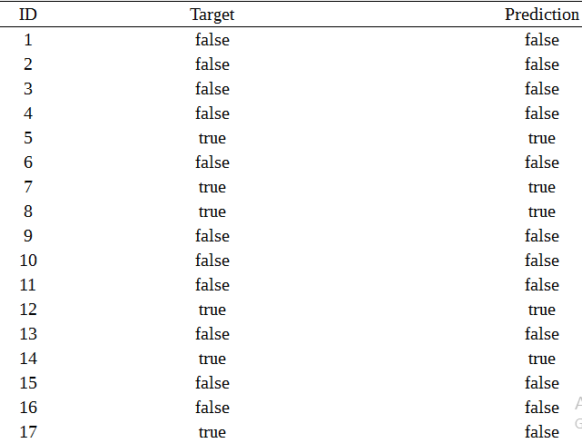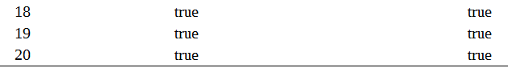

a. A confusion matrix and the misclassification rate

b. The average class accuracy (harmonic mean)

c. The precision, recall, and F1 measure

2. The table below shows the predictions made for a continuous target feature by two different prediction models for a test dataset.

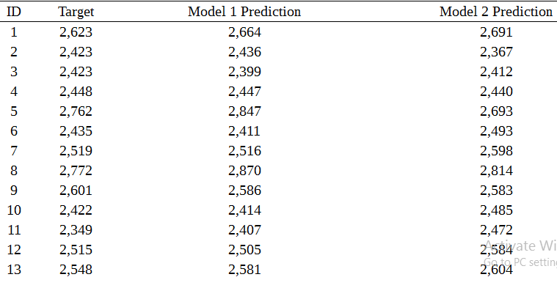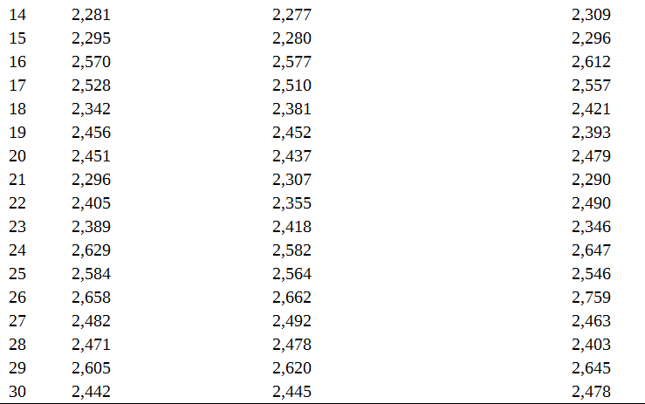

a. Based on these predictions, calculate the evaluation measures listed below for each model.

   i. The sum of squared errors

  ii. RMSE

b. Based on the evaluation measures calculated, which model do you think is performing better for this dataset?